Exclear project

karthikmuskula73@gmail.com // Mentor Of the Project

Project Name -- Bankruptcy Prevention

Business Objective:

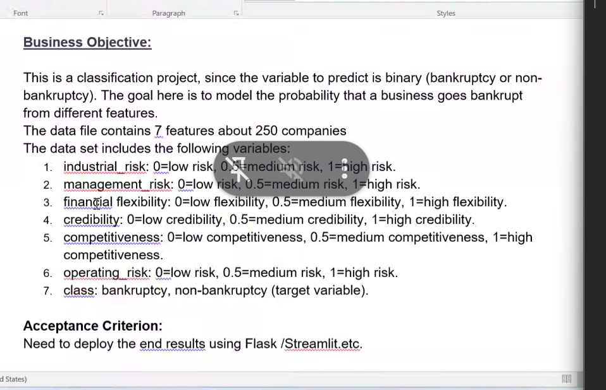

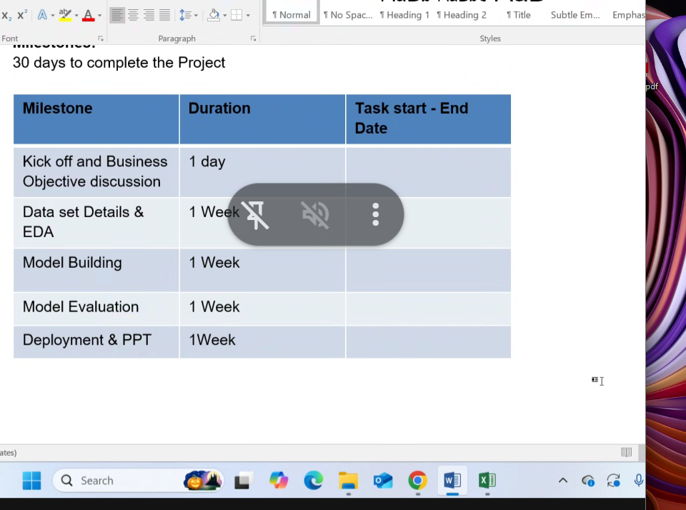
Every Wednesday 6 Pm Meeting

✅ **Summary & Next Steps:**
- Compared **Random Forest, Logistic Regression, and SVM** for bankruptcy prediction.
- Applied **GridSearchCV** for hyperparameter tuning of Random Forest.
- Model evaluation metrics include Accuracy, Precision, Recall, and F1-score.
- Validate further on **real-world financial datasets** for generalization.
- Consider using **Explainable AI** (e.g., SHAP, LIME) to interpret results for stakeholders.

